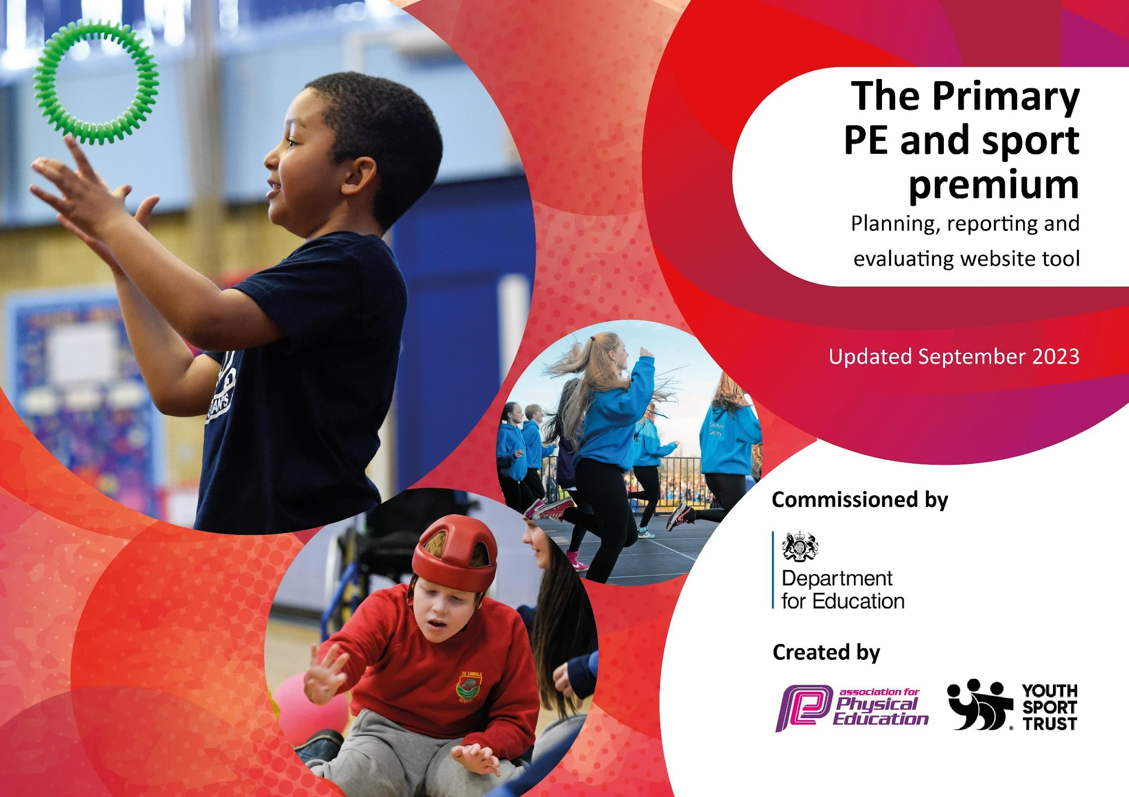

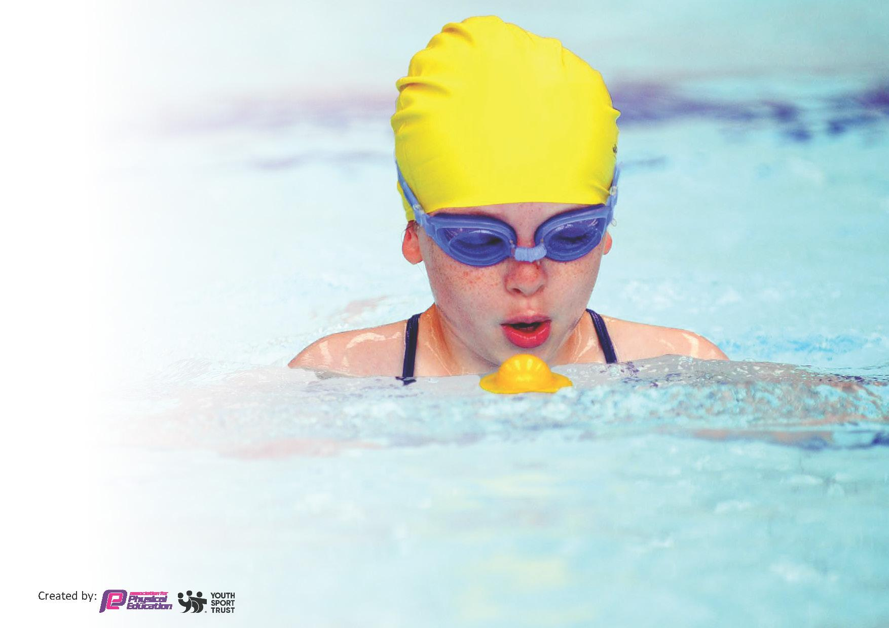
This template can be used for multiple purposes:
by:
- It enables schools to effectively plan their use of the Primary PE and sport premium
- It helps schools to meet the requirements (as set out in guidance) to publish information on their Primary PE and sport premium
- It will be an effective document to support Ofsted inspections enabling schools to evidence progress in Physical Education (PE) and evidence swimming attainment, which forms part of the PE National Curriculum. We would recommend schools consider
the Intent, Implementation and Impact of any spend, as examined within the Education Inspection Framework.

It is important that your grant is used effectively and based on school need.

Schools must use the funding to make additional and sustainable
improvements to the quality of the PE, School Sport and Physical Activity (PESSPA)
they offer. This means that you should use the Primary PE and sport premium to:

- Build capacity and capability within the school to ensure that improvements made now will benefit pupils joining the school in future years
- Develop or add to the PESSPA activities that your school already offers.

The Primary PE and sport premium should not be used to fund capital spend projects; the school’s core budget should fund these. Further detail on capital expenditure can be found in the updated Primary PE and sport premium guidance.

The Primary PE and sport premium guidance, outlines 5 key priorities that funding should be used towards. It is not
necessary that spending has to meet all the key priorities, you should select the priorities that you aim to use any funding towards.

Although completing this template is not a requirement for schools, schools are required to publish details of how they spend this funding. Schools must also outline what the impact this funding has had on pupils’ PE and sport participation and attainment and how any spending will be sustainable in the future. All funding must be spent by 31st July 2024.

The Department for Education has worked closely with the Association for Physical Education (afPE) and the Youth Sport Trust (YST) to develop this template and encourages schools to use it. This template is an effective way of meeting the reporting requirements of the Primary PE and sport premium.
Review of last year’s spend and key achievements (2022/2023)

We recommend you start by reflecting on the impact of current provision and reviewing your previous spend.

Activity/Action | Impact | Comments
Increase number of children participating in regular exercise.  Provide children with a range of sporting opportunities in local sporting festivals and competitions. Also, provide children with Trust sporting events throughout the academic year.  To ensure all staff have access to training to increase confidence, knowledge and skills of all staff in teaching PE. | Key indicator 1  Primary sports expertise used to design active lunchtimes and upskill staff in the delivery of technical sports guidance.  Key indicator 2,4 & 5  Children have taken part in a range of sporting fixtures and events.  Key indicator 3  Primary sports employed to model excellent practice for staff less familiar with some aspects of instruction.  Get Set for PE used collaboratively with other trust schools to instruct teachers on best practice and provide a library of high-quality resources. | All staff aware of the benefits of range of lunchtime activities and how it can be a tool to increase the amount of physical activity that children take part in during their break and lunchtimes.  Engagement with this is due to be increased next year for Beaford as new PE lead is moving from within TEAM multi-academy trust.  Staff reported increased confidence in the delivery of all sports covered and an observed improvement in the sessions and outcomes for children.

Key priorities and Planning
This planning template will allow schools to accurately plan their spending.

Action – what are you planning to do | Who does this action impact? | Key indicator to meet | Impacts and how sustainability will be achieved? | Cost linked to the action
Developing active play principles during break and lunchtime for all pupils. Supporting the OPAL environment.  To ensure children have access to a broad, rich and engaging curriculum using Get Set for PE.  Children to get a range of extra curricular sports events which engage them and raise the profile of PE.  Use expert coaches to teach specialist lessons and give teachers CPD | Lunchtime MTA’s / teaching staff.  pupils – as they will take part.  Teaching staff, teaching assistance and pupils who will be part of the lessons.  Children and families.  Children and staff observing | Key indicator 1, 2 & 4  Broader experience of a range of sports and activities offered to all pupils at break and lunchtime. Increase in the amount of physical activity children are doing during the school day to meet the Officer guidelines that all children and young people aged 5 to 18 engage in at least 60 minutes of physical activity per day, of which 30 minutes should be in school.  Key indicator 3  During the academic year, children get the opportunity to be taught in a range of sports across the curriculum as well as take part in wider opportunities across the trust. This is additional sporting opportunities which include some of the following: Tennis, cricket, football, dance, outdoor events, athletics and the swimming.  Key Indicator 4 and 5  The profile of PE is raised across the school for whole school improvement. Children are increasingly able to access competitive sport.  Key Indicators 1+3  ARC and ECFC staff are able to model expertise for our staff’s development and the children experience the enhancement of a professional environment. | More pupils meeting their daily physical activity goal, more pupils encouraged to take part in Opal-type play to build teamwork, problem solving and communication skills.  Children broaden their sporting experiences to help increase the likelihood of them finding a sport that they enjoy. This has helped to raise to profile of PE across the school and create engagement and excitement for physical activity.  Children engaged with cross trust sporting events which gave them the implicit benefits of competitive sports with the wider community. | £2500 on some materials to support all weather play.  £3000 for scheme, new equipments and travel.  £2000 Travel, swimming and event costs  £3000

Key achievements 2023-2024
This template will be completed at the end of the academic year and will showcase the key achievements schools have made with their Primary PE and sport premium spending.

Activity/Action | Impact | Comments
Go Beyond residentials offered to vulnerable children.  Cross trust and local sporting events participated in: Cricket, football, swimming, tennis,  Sporting afterschool clubs were delivered  Staff are more confident to deliver PE curriculum.  All key stage 2 children had funded swimming lessons.  Bikeability catch-up targeted and supported children with fundamental skills gaps. | Vulnerable children have been able to achieve sporting success in a supportive environment, building self esteem and engagement.  .  Children able to experience more competitive sport and develop community links, especially those about to transition to Secondary school. Beaford took part in its first ever swimming gala, which the children that took part were extremely proud of.  Children were able to access expert coaching outside of school time, parent survey showed there was a demand for clubs so will be part of plan for next year.  Observations show staff using the PE scheme and strategies from coaches to support their teaching in areas of PE they are less confident with.  Post-covid there was a drop in the number of children that could swim 25m. These helped to increase the number that could achieve the target.  All year 5 and 6 children were able to become proficient cyclists.

Swimming Data
Meeting National Curriculum requirements for swimming and water safety.
Priority should always be given to ensuring that pupils can perform safe self-rescue even if they do not fully meet the first two requirements of the National Curriculum programme of study

Question | Stats: | Further context  Relative to local challenges
What percentage of your current Year 6 cohort can swim competently, confidently and proficiently over a distance of at least 25 metres? | 63 % | This cohort had swimming in y4, 5 and 6 as there was a noticeable drop in swimming attainment.  4 children that were non-swimmers were all on SEN register.
What percentage of your current Year 6 cohort can use a range of strokes effectively [for example, front crawl, backstroke, and breaststroke]? | 54 %

What percentage of your current Year 6 cohort are able to perform safe self-rescue in different water-based situations? | 63 %
If your school’s swimming data is below national expectation, you can choose to use the Primary PE and sport premium to provide additional top-up sessions for those pupils that did not meet National Curriculum  requirements after the completion of core lessons. Have you done this? | No
Have you provided CPD to improve the knowledge and confidence of staff to be able to teach swimming and water safety? | No | We used a local facility called Tarka who provide their own qualified swim instructors to teach the children during the lessons and a parent volunteer who is a trained swimming instructor to ensure the weaker swimmers had more focussed adult support.

Signed off by:

Head Teacher: | George Myers
Subject Leader or the individual responsible for the Primary PE and sport premium: | Adam Northmore
Governor:
Date: 7/24

